**Project Design Phase-II**

**Technology Stack (Architecture & Stack)**

|  |  |
| --- | --- |
| Date | 03 October 2022 |
| Team ID | PNT2022TMID31896 |
| Project Name | Global Sales Data Analytics |
| Maximum Marks | 4 Marks |

**Technical Architecture:**

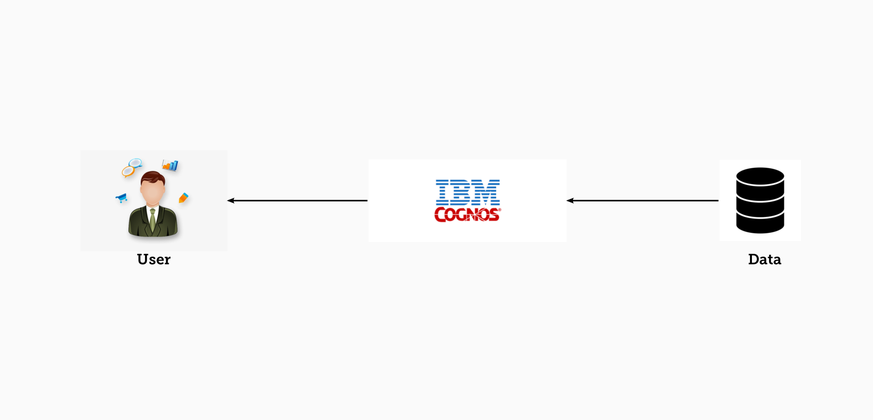

**Table-1 : Components & Technologies:**

|  |  |  |  |
| --- | --- | --- | --- |
| **S.No** | **Component** | **Description** | **Technology** |
|  | User Interface | How user interacts with application e.g.  Web UI, Mobile App, Chatbot etc. | IBM Cognos |
|  | Storage (Cloud) | Customer sales data is uploaded in cloud through interface. | IBM Cloud |
|  | Working with dataset | Uploading and processing data. | IBM Cognos + IBM Cloud |
|  | Data Exploration | Uploaded data is explored for analysing | IBM Cognos |
|  | Data Visualization | Different types of visualization are created according to customer requirements. | IBM Cognos Dashboard |
|  | Cloud Database | Database Service on Cloud | IBM DB2, IBM Cloudant etc. |
|  | View | User logins to application to view visualizations for uploaded data. | IBM Cognos Dashboard |

**Table-2: Application Characteristics:**

| **S.No** | **Characteristics** | **Description** | **Technology** |
| --- | --- | --- | --- |
|  | Open-Source Frameworks | List the open-source frameworks used | IBM Cognos, IBM Cloud |
|  | Security Implementations | List all the security / access controls implemented, use of firewalls etc. | Active directory |
|  | Scalable Architecture | Justify the scalability of architecture | Web 3.0 IBM Cloud. |
|  | Availability | Ability to create complex, multi-page layouts using different data sources. High performance data access across all sources. | Cognos Business Intelligence Server. |
|  | Performance | Design consideration for the performance of the application | Performance management hub. |